Game Design Document

Fill up the following document

1. Write the title of your project.

Billy stop!

1. What is the goal of the game?

To dodge billy’s toys until he runs out

1. Write a brief story of your game.

Billy hates kids so hes throwing toys

Billy throws faster and runs faster and laughs as more people join the game

The teachers yell at billy more

The parents get more mad at billy

Bily starts throwing more toys when more children join the game

When you join the game you can choose your name and your icon will be a randomized picture of a child

1. Which are the playing characters of this game?

* Playing characters are the ones who respond to the user based on the input from the user.
* Cars, monkeys, dinos, wizards, etc., are the playing characters in the game.

|  |  |  |
| --- | --- | --- |
| Number | Character Name | What can this character do? |
| 1 |  |  |
| 2 | Any other children | Dodge flying toys from billy |
| 3 |  |  |
| 4 |  |  |
| 5 |  |  |
| 6 |  |  |
| 7 |  |  |
| 8 |  |  |

1. Which are the Non-Playing Characters of this game?

* Non-Playing characters are the ones that don't have an action or behavior when the user interacts with the game.
* Hurdles, stones, bananas, coins, etc., are non-playing characters in the game.

|  |  |  |
| --- | --- | --- |
| Number | Character Name | What can this character do? |
| 1 | teacher | Say stop |
| 2 | parents | Scold billy |
| 3 | billy | throw toys |
| 4 |  |  |
| 5 |  |  |
| 6 |  |  |
| 7 |  |  |
| 8 |  |  |

Draw your imagination of this game. What does this game look like?

* Draw the game either on your computer or on paper.
* Add images of the game scenes to show each of the playing and non-playing characters at least once.

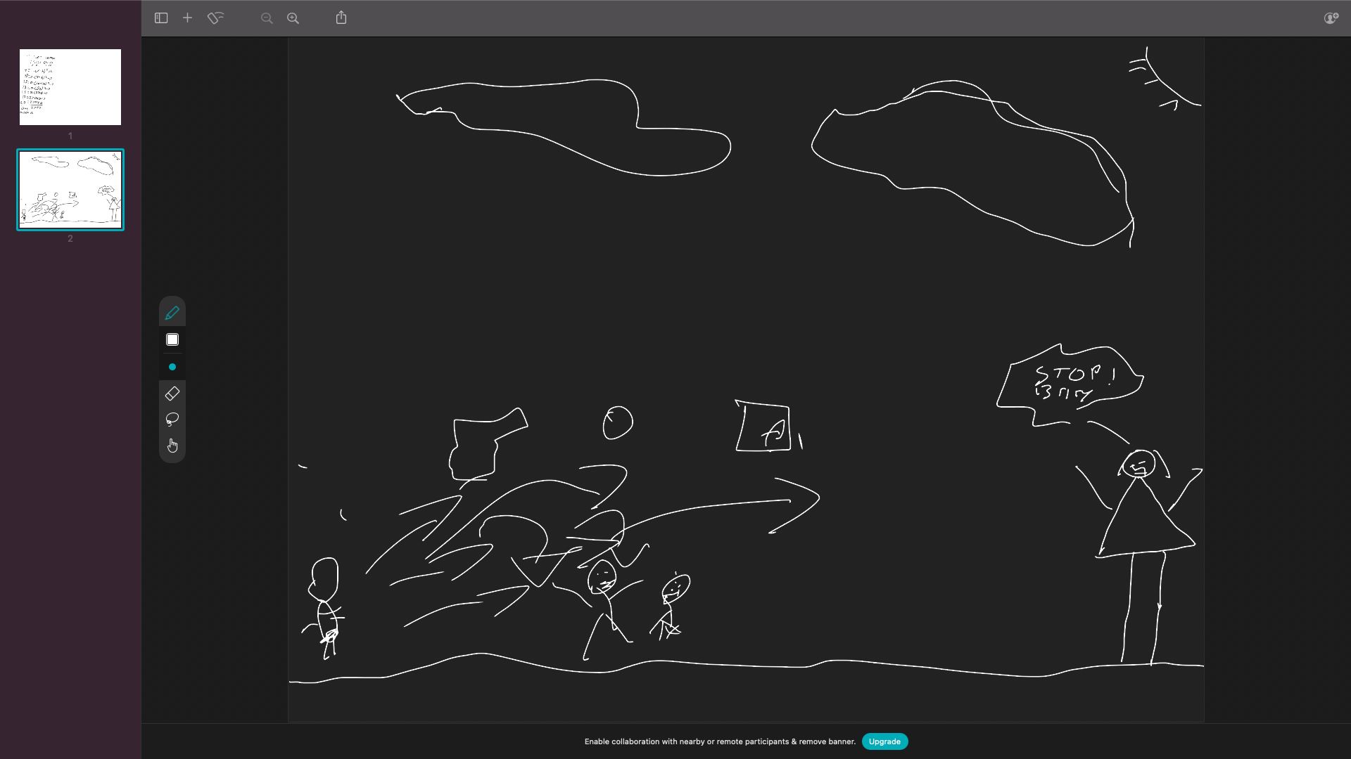

How do you plan to make your game engaging? It will be competitive due to its multiplayer nature